

S.O.S. – Save Our Septic® Program

with RetroFAST® Septic System Enhancement

**Site Evaluation/Registration Report**

This form must be filled out in its entirety and submitted to Bio-Microbics prior to any warranty taking effect between Bio-Microbics and its Authorized Distributor

***Questions that must be answered by the property owner:***

1. Is system at least 5 years old? □ YES □ NO
2. Is there visible ponding of sewage on the ground surface at or near the lateral field(s)? □ YES □ NO
   1. Does this ponding only take place during certain periods of the year?
   2. Have there been other areas of the property or adjacent properties that have ever shown evidence of standing water/ soggy ground or high ground water? □ YES □ NO If YES, explain:
3. Has sewage ever backed up into the home/building? □ YES □ NO
4. Has the system ever had repairs/modifications done before? □ YES □ NO If YES, explain: _
5. How many people currently live in the home?
6. Does anyone in the household use pharmaceutical drugs on a regular or irregular basis? □ YES □ NO
   1. If possible, please provide the name of the drug(s):
7. Are water usage records available? □ YES □ NO If YES, please provide average daily flow: _
8. Any “unusual” activities that contribute waste to the system (hot tub, home catering service, large gatherings, photo lab, etc.)? □ YES □ NO

If YES, explain:

1. Has system operated for at least 5 years without issue other than previously described? □ YES □ NO

If NO, explain:

1. Is an irrigation system used for effluent disposal? □ YES □ NO
2. Please explain any other aspects of the system/history that you feel are pertinent:

***The information supplied on this document is truthful and accurate to the best of my knowledge:***

Property Owner: Date:

Authorized Distributor/Dealer: Date:

**RetroFAST® Serial Number: Date of Installation:**

**INSTALLATION SITE**

|  |  |
| --- | --- |
| **NAME** |  |
| **ADDRESS** |  |
| **CITY/STATE/ZIP** |  |
| **PHONE/FAX** |  |

**INSTALLER**

|  |  |
| --- | --- |
| **NAME** |  |
| **ADDRESS** |  |
| **CITY/STATE/ZIP** |  |
| **PHONE/FAX** |  |

**PLEASE PROVIDE THE FOLLOWING SITE INSTALLATION PICTURES WITH EACH PRODUCT REGISTRATION**

(Digital Photos should be emailed to [onsite@biomicrobics.com](mailto:onsite@biomicrobics.com) with the above information OR Printed Photos can be mailed with this form to the attention of **Bio-Microbics Field Services Department** at 8450 Cole Parkway, Shawnee, Kansas, 66227**:**

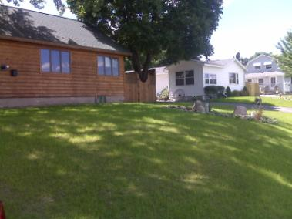 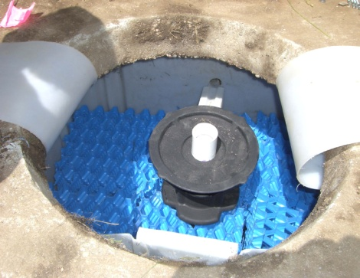 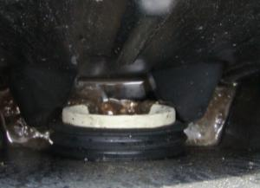

OUTLET PIPE INSTALLED

INTO RETROFAST®

Installation of internal parts

BEFORE INSTALLATION OVERALL SITE

INSTALLATION OF INTERNAL PARTS

VENT

AIR LINE GLUED TO AIRLIFT COUPLING

VENT(s)

Blower piping

BEFORE BACKFILL

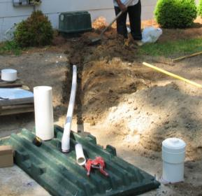 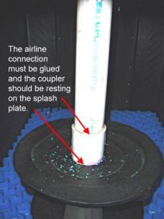 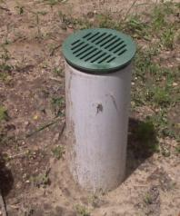

BLOWER PIPING TO UNIT

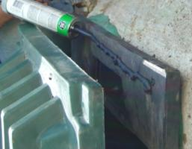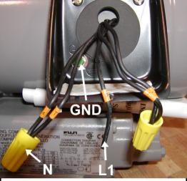 

AFTER INSTALLATION OVERALL SITE

LINER & LID ARE SEALED TO TANK

BLOWER WIRING